**Professional Certificate Program in Full Stack Development – MERN Stack**

Lab Guide

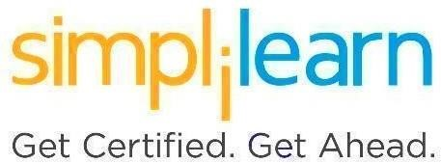

This section will guide you to:

* Use labs to execute all demos included in this course

This lab has two subsections, namely:

* 1. Starting practice labs on LMS
  2. Checking the versions of different technologies

**Step 1: Starting practice labs on LMS**

* Login to Simplilearn LMS
* Navigate to the respective course
* On the left, you will find multiple tabs to access the course components

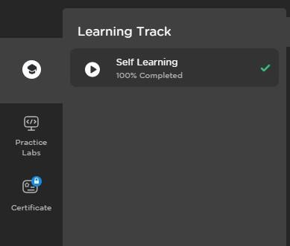

* Navigate to **PRACTICE LABS** tab and select **MERN Stack Lab**

* Launch the lab using the **LAUNCH LAB** option

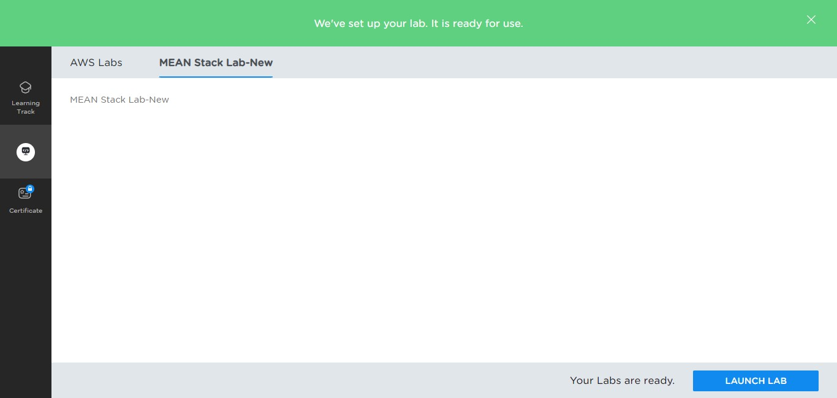

* Once the lab instance is started, you will see the below interface:

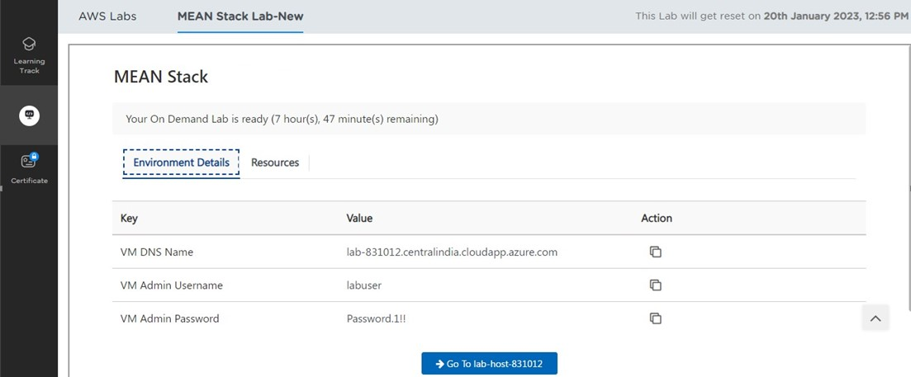

* Once you click on **Go To lab-host** option, the lab will be launched in a new window:

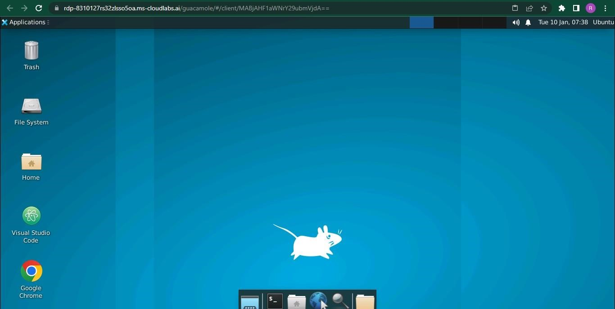

**Step 2: Checking the versions of the technologies**

* Open the terminal and use the following commands to check the version:

|  |  |  |
| --- | --- | --- |
| **Tools** | **Versions** | **Commands** |
| Git | 2.34.1 | git --version |
| HTML/CSS | 5 | NA |
| Bootstrap | 4 | NA |
| React | 18.0.2 | NA |
| NodeJS | 18.12.1 | node -v |
| MySQL | 10.6.11 | mysql -V |
| MongoDB | 6.0.3 | mongod --version |
| Mocha, Chai | 10.1.0, 4.5 | NA |
| Docker | 20.10.17 | docker version |
| Jenkins | 2.375.1 | jenkins --version |